[Working title]: Yellow monkeYflower genotype and phenotype interactions with foliar fungal symbionts in common gardens

Bolívar Aponte Rolón1,✉, Kathleen G. Ferris2, and Sunshine A. Van Bael2

April 11, 2024

1 Tulane University  
2 Department of Ecology and Evolutionary Biology, Tulane University, 6823 St. Charles Avenue, New Orleans, LA 70118

✉ Correspondence: [Bolívar Aponte Rolón <baponterolon@tulane.edu>](mailto:baponterolon@tulane.edu)

## 0.1 Keywords

# 1. Abstract

# 2. Introduction

Evolutionary dynamics are significantly shaped by phenotypic plasticity and genetic adaptation, with both mechanisms playing crucial roles in facilitating plant survival and adaptation to a changing climate (Franks et al., 2014; Jump & Peñuelas, 2005). The effect of climate change on plastic and evolutionary responses is evident and accelerating (Franks et al., 2014; Intergovernmental Panel On Climate Change, 2023). Phenotypic plasticity and genetic adaptation are predicted to mitigate some of the effects of climate change, however, evidence supports that the rate of evolution may not keep pace, leading to the extinction of species (Urban et al., 2014). The diversity and distribution of plants will be affected, resulting in “winners” and “losers” that are optimally or ill-adapted to an uncertain climate future (Pecl et al., 2017). Local adaptation and genetic variation have been extensively studied in the context of spatial and temporal changes, but the role of symbiotic relationships in plant adaptation is less understood [Peay et al. (2016); Kivlin et al. (2022); Mojica et al. (2012); ADD OTHER CITES]. Plants’ ability to adapt to novel environments has been facilitated by their symbiotic relationships with fungi and bacteria (reviewed in Peay et al., 2016; Remy et al., 1994). From colonization of land by plants in consort with arbuscular mycorrhizal root mutualists aiding in nutrient acquisition [peay2016; Remy et al. (1994)], to the benefits fungal symbionts provide against pathogen resistance (Clay, 1996; Estrada et al., 2013; Mejía et al., 2008; Rasmussen et al., 2008), and stress tolerance (Giauque et al., 2019; Peay et al., 2016), the potential for fungi to enhance plant fitness is vast. Nonetheless, the potential benefits are contingent on host plant identity and genetics and the fungal functional guild observed [Kivlin et al. (2022); MORE CITE].

The phyllosphere comprises of bacterial and fungal symbionts on the surface and inside leaf tissue. Foliar endophytic fungi (FEF) refer to are a diverse group that lives *within* leaves (Arnold & Engelbrecht, 2007). They are mostly asymptomatic, but are known to alter plants’ response to stressful environments, such as drought (Aimone et al., 2023; Giauque et al., 2019; Giauque & Hawkes, 2013), herbivory [Mejía et al. (2008); CITE], and pathogen damage (Busby et al., 2016; Mejía et al., 2014). The phyllosphere and rhizosphere can effectively expand the host plants’ phenotype through genetic and metabolic pathways (reviewed in Hawkes et al., 2021; Kaddes et al., 2019). In turn, host phenotype and genetics shape the phylosphere (Horton et al., 2014; Kivlin et al., 2022; Tellez et al., 2022; VanWallendael et al., 2022) to such degree that host genetics can predict rhizosphre communities (Deng et al., 2021; Horton et al., 2014). The composition of the phyllosphere can also be altered throughout the growing season by host genetics (VanWallendael et al., 2022). A significant portion of our knowledge about the affinity of FEF communities to host genetics comes from studies focused on vertically transmitted endophytes (transferred from parent to offspring, e.g. *Epiclhöe* spp.) and horizontally transmitted endophytes (acquired from the environment, e.g. *Cladosporium* spp.) in grasses (Clay, 1996; Mathew et al., 2023; Ranelli et al., 2015; Song et al., 2016). Concurrently, other studies focused on how leaf traits (e.g. leaf mass per area, leaf shape) along a growth versus persistence gradient in tropical tress can influence FEF community colonization (Kitajima et al., 2013; Poorter & Bongers, 2006; Tellez et al., 2022; Wright et al., 2004). This has enabled a deeper understanding of how leaf traits interact with FEF communities, but the role FEF play in the local adaptation and phenotypic plasticity of their hosts is less clear (Cordovez et al., 2019) due to work on non-model systems. The ability to have a genetic adaptation or plastic response that increases the potential for establishing beneficial symbionts, above or below-ground, can be crucial for plant survival and adaptation to changing environments. Studying the interaction between plant genotype and phenotype with FEF communities is essential in the fields of ecology and evolutionary biology.

The *Mimulus guttatus* species complex is an ideal system to study interactions between leaf phenotype, host genetics, and FEF communities [Twyford & Friedman (2015); Wu et al. (2008)). It comprises about a dozen closely related species (Coughlan et al., 2021; Wu et al., 2008), where two interfertile species, *M. guttatus* and *M. laciniatus*, exhibit strong differences in leaf morphology controlled by overlapping genetic regions, suggesting that large-effect loci underlie this trait (Ferris et al., 2015). Additionally, the contrasting habitats of *M. guttatus*, moist seeps, and *M. laciniatus*, granite outcrops throughout the Sierra Nevada mountain range in California provide an opportunity to explore the role of leaf phenotype and host genetics in conforming FEF communities (Tataru et al., 2023). Through a genome-wide association study (GWAS), Deng et al., (2021) showed how the bacterial rhizosphere of *Sorghum bicolor* (L.) can be predicted based on host genetics. McIntosh et al., (2024) found that coastal perennial and montane annual *M. guttatus* harbored distinct soil fungal communities, despite the absences of host local adaptation to underground conditions. This suggests that species divergence in life history and associated traits can shape responsiveness to microbial symbionts (McIntosh et al., 2024). The potential effects of FEF on *Mimulus* hosts have not been thoroughly investigated, despite the possibility that the microbiome-expanded phenotype may influence its response to selection pressures. To our knowledge, no studies have considered host genetics and leaf shape influence FEF community composition in *Mimulus* spp. leaf tissue.

In this study, we asked: 1) How do FEF communities differ in sympatric populations of *M. guttatus* and *M. laciniatus* grown in common gardens; 2) What is the role of leaf morphology in FEF colonization of *M. guttatus* and *M. laciniatus*? 3) Are there specific genetic loci associated with FEF communities in *Mimulus* spp.? To answer these questions we conducted a reciprocal transplant experiment in Yosemite National Park, CA, USA. We used locally adapted genotypes of *Mimulus guttatus* (syn. *Erythranthe guttata* (Fisch. ex DC.) G.L. Nesom) and *Mimulus laciniatus* (syn. *Erythranthe laciniata* (Fisch. ex DC.) G.L. Nesom) as parental lines and their F2 hybrids to understand the contributions of host plant genetics and phenotype, and the environment to FEF community composition. Crossing parental lines and generating F2 hybrids allowed us to decouple leaf shape from host genetics and understand the relative importance of each component in shaping FEF communities. We predicted genotypes adapted to their local environment would harbor greater levels of FEF abundance and community composition than non-locals. We expected that granite outcrop sites would have less FEF abundance and diversity than meadow sites due to the harsher environmental conditions.

# 3. Materials and Methods

### 3.0.1 Field experiment design

The reciprocal transplant was conducted in Yosemite National Park, CA, USA from May to July 2021. It involved arranging 24 individuals into 25 randomized blocks in an 8 x 15 cm formation with a separation of 2.5 cm. Our study closely replicated experiments carried out in the years 2013 and 2019 by Ferris and Willis (-Ferris & Willis (2018)) as well as Tataru and Ferris (-Tataru et al. (2023)). The experiment utilized four different study sites: two meadows where native *M. guttatus* grows near a standing seep (Little Meadow “Meadow 1” [37.767781, -119.772720; elevation: 2013 m a.s.l.], Crane Flat “Meadow 2” [37.755968, -119.803031; elevation: 1879 m a.s.l.) and two granite outcrops hosting native *M.laciniatus* (Olmstead Point “Granite 1” [37.810700, -119485200; elevation: 2572 m a.s.l.), Yosemite Creek “Granite 2” [37843702, -119573120; elevation: 2424 m a.s.l.]).

The reciprocal transplants used generations of hybrids created from inbred *M. guttatus* (YVO 18; 37.723366, -119.746433; elevation: 1645 m a.s.l.) and *M. laciniatus* lines (WLF 47; 37.841533, -119.59385; elevation: 2436 m a.s.l.). Parental lines were locally adapted to moist seep/meadow and granite outcrops, respectively, not the experimental sites. Hybrids were created by crossing the parental inbred lines to generate F1 hybrids, which were then self-fertilized to generate F2 seeds used in this study. Plant breeding was conducted in the greenhouse at Tulane University (New Orleans, LA, USA). We incorporated both reciprocal hybrid crosses: F2 WLF 47 maternal x YVO 18 paternal (“F2 WxY”) and F2 YVO 18 maternal x WLF 47 paternal (“F2 YxW”). Each block was composed of 6 of each reciprocal F2 hybrid and 6 of each parent, totaling 150 of each genotype per habitat (i.e. meadow and granite) and 2,400 overall experimental plants.

### 3.0.2 Seed preparation and germination

We cold-stratified parental *M. laciniatus* and hybrid seeds at 4°C for 10 days and parental *M. guttatus* seeds at 4°C for 5 days to break dormancy and synchronize germination in soil (Sunshine Mix #4 Professional Growing Mix, Sun Gro). Then, we germinated seeds for one week in a greenhouse. Cold-stratification and germination was carried out at the University of California (UC) Davis. Following germination, cotyledons were carefully placed into the randomized block designs using forceps and placed wooden toothpicks to track individuals. We attributed mortality within the first week to transplant shock and dead germinates were replaced.

## 3.1 Leaf shape measurement

For each plant, we obtained measurements leaf lobe index (LBI) as our measure of leaf shape (Ferris et al., 2015). We destructively sampled individuals from experimental block by uprooting and placing samples in Ziploc bags and preserving in ice chest until ready to process (~ 2-3 hrs). We ensured samples did not came into direct contact with ice by placing a barrier (e.g., towel) to avoid tissue damage. We prepared and preserved samples at the UC Merced Yosemite Field Station. Fist, we cleaned plants with tap water to remove all soil and debris remnants from the leaves and roots. We removed all healthy leaves (~ 5 - 7) from the stems. We used a transparency film to hold the most notably lobed leaf in place and flatten, after which we took a digital photograph for further analysis. To calculate the LBI, we followed Ferris et al., (2015). Briefly, leaf lobing is calculated as the convex hull area minus the true leaf area divided by convex hull area of a digital photograph of a leaf in ImageJ [v1.52r; Schneider et al. (2012)].

## 3.2 Molecular Work

### 3.2.1 Tissue preservation

After collecting the leaf shape measurements. We preserved the whole leaf lamina from plants due to their small size, in contrast to Arnold et al., (2003) and Tellez et al., (2022). Leaf lamina were sterilized with sequential washes in 95% EtOH (10 s), 0.5% sodium hypochlorite (NaOCl) (60 s), and 70% EtOH (60 s) and air dried under sterile conditions. The maximum amount of leaf lamina was preserved in sterile 2 mL tubes with ~ 1 mL CTAB solution (1 M Tris–HCl pH 8, 5 M NaCl, 0.5 M EDTA, and 20 g CTAB). The leaf tissue in CTAB solution was used for amplicon sequencing (described in detail below). All leaf tissue handling was performed in a sterile environment with an alcohol burner lamp inside a portable biosafety cabinet. All surfaces were previously sterilized sequentially with 0.5% NaOCl, 95% EtOH, and 70% EtOH. We surface sterilized surfaces and instruments in between sample handling to prevent cross contamination.

### 3.2.2 Amplicon sequencing

We stored leaf tissue in CTAB solution for 12 months at 20°C before extracting DNA at Tulane University. We followed the DNA extraction protocol and quality control assays described in Chapter 2. Libraries were sequenced on the Illumina NextSeq 1000 platform with the P1 reagent kit (2 × 150 bp) at Duke Genome Sequencing and Analysis Core Facility (Durham, NC, USA).

### 3.2.3 Sequence-based genotyping

We genotyped individuals following a modified ddRADseq protocol, Rapture (Ali et al., 2016; Nelson, 2019), for the identification of single nucleotide polymorphisms (SNPs). We allotted the remaining DNA extracted from leaf tissue to the ddRADseq library preparation. The Rapture protocol call for a two step digestion process, for which we used the restriction enzyme *Bfal-HF* (R0568S, New England Biolabs, Ipswich, MA, USA) in the first DNA digestion, and *PstI* (R0140L, New England Biolabs, Ipswich, MA, USA) in the second digestion. We then ligated annealed oligos to each sample. We prepared ddRAD libraries using the NEBNext® Ultra™ II DNA Library Prep Kit for Illumina® (E7645S, New England Biolabs, Ipswich, MA, USA) with the *i7* oligos from NEBNext® Multiplex Oligos for Illumina® (E7335S, New England Biolabs, Ipswich, MA, USA) and a custom *i5* barcoded oligos (IDT, Coralville, Iowa, USA; see Supplementary Materials). We sequenced the library on the Illumina NovaSeq X Plus platform at Duke Genome Sequencing and Analysis Core Facility (Durham, NC, USA).

### 3.2.4 Bioinformatic analyses

#### 3.2.4.1 ITS amplicons

Similar to Chapter 2, we used FastQc v0.12.1 [ v0.12.1; Andrews et al. (2010)] and MultiQC (Ewels et al., 2016) tools to assess the quality of the reads. A total of 20,685,544 total ITS1 reads yielded from 318 (including 31 controls) libraries sequenced in a single run. We modified the open-source DADA2 bioinformatic pipeline for our data set (Callahan et al., 2016). Our initial quality assessment revealed both, forward and reverse reads,were of high quality. We filtered our reads for ambiguous calls before removing the adapters by using filterAndTrim function and argument maxN = 0 from the dada2 package [v1.28.0; Callahan et al. (2016)]. We removed forward and reverse primer adapters (and their reverse compliments) and eliminated reads shorter than 10 bp using the cutadapt tool (v4.6, Martin, 2011). Following this filtering process, we re-evaluated read quality and then applied stringent filter and truncation parameters based on maximum expected errors (maxEE) rather than read length (Edgar & Flyvbjerg, 2015) to ensure high-quality taxonomy assignment later on. For this we set set the arguments trunQ = 2, maxEE = c(2,2) for forward and reverse reads, and minimum read length of 50 bp with minLen = 50 in the used the filterAndTrim function (Callahan et al., 2016). After this filter, we dereplicated reads with the derepFastq function and merged pairs using mergePairs functions with an overlap of 12 bp, minimum. We then inferred composition of the samples with dada function, which applies the DADA algorithm (Callahan et al., 2016; Rosen et al., 2012). We removed chimeras via the “consensus”method with the removeBimeraDenovo function and ultimately we used the assignTaxonomy function to assign taxonomy the amplicon sequence variants (ASV) referenced against the UNITE database (Abarenkov et al., 2023). After taxonomy assignment we used the phyloseq package (McMurdie & Holmes, 2013) to create a phyloseq object for downstream analyses.

We decontaminated ITS amplicons and performed all post-quality bioinformatic steps as described in Chapter 2.

#### 3.2.4.2 Single Nucleotide Polymorphisms (SNPs)

The *i7* demultiplexing was performed by Duke Genome Sequencing and Analysis Core Facility (Durham, NC, USA). The *i5* demultiplexing and generation of *vcf* files was done following the Nelson (2020). NEEDS MORE

## 3.3 Statistical Analyses

### 3.3.1 Community Diversity

We standardized the libraries using repeated rarefaction, as described by Cameron et al., (2021). Following an assessment of Good’s coverage and a qualitative evaluation of the libraries, we established a sequence depth of 1300 reads to ensure balanced coverage and sample breadth. This approach facilitated a proportional representation of observed sequences from host species and provided a robust characterization of random variation inherent in the rarefaction process (Cameron et al., 2021; Schloss, 2024). Subsequently, we generated 50 rarefied abundance matrices without replacement utilizing the mirl function from the mirlyn package. Next, we computed alpha diversity per sample as Hill orders -observed richness (q = 0), exponentiated Shannon’s entropy (q = 1), and Inverse Simpson’s Diversity (q =2)— using our modified version of the alphadivDF function based on work by Cameron et al., [-Cameron et al. (2021); see custom script in Supplementary material] that wraps common diversity indices in vegan package utility functions (Oksanen et al., 2022). .

For beta diversity analyses, we performed a Hellinger transformation on the rarefied abundance matrices and calculated a Bray-Curtis dissimilarity matrix for each, then we applied a distance-based Redundancy Analysis (dbRDA) on dissimilarities to statistically compare similarities within each host species per site (Anderson, 2017; Legendre & Anderson, 1999; McArdle & Anderson, 2001).

Our dbRDA model consisted of terms logLBI, genotype, and habitat type. The leaf shape data was not randomized or sub-sampled to match rarefied dataset, the original values applied to all 50 rarefied matrices. To select the best model, we evaluated the marginal significance of constraining variables after 999 permutations with function anova.cca (Legendre et al., 2011; Legendre & Legendre, 2012; Oksanen et al., 2022). We evaluated the homogeneous dispersion of variances with a permutational analysis of multivariate dispersion (PERMDISP) using the betadisper with parameter type = "median", and permutest functions from vegan, the latter with 999 permutations (Oksanen et al., 2022). We used a post-hoc Tukey’s test to compare the differences in the dispersion of the FEF communities among genotypes and habitat types.

### 3.3.2 Leaf shape

We checked for normality and homoscedasticity of the LBI measurements. We used Shapiro-Wilk and Fligner-Killen tests from the stats package (R Core Team, 2024) to check for normality and homoscedasticity, respectively. We established that the leaf lobe index data was not normally distributed and not homoscedastic and perfomed log-transformation. We then used non-parametric tests, the Wilcoxon Rank Sum test, to compare LBI means among genotypes. We used the compare_means and stat_compare_meansfunctions from the ggpubr package (Kassambara, 2023) to perform these tests and properly visualize them. We adjusted *p* values to account for false discovery rates in multiple comparisons by using “BH” method (Benjamini & Hochberg, 1995).

All statistical analyses were performed in *R* programming language [v.4.3.3; R Core Team (2024)]. We present FEF community data for 287 samples and SNPs data for NNNN samples. We present the log-transformed LBI from and samples from the larger common garden described above (*n* = 793), which include samples with FEF community data (*n* = 236). The FEF community data is presented at the plant/sample level (*n* = 287).

# 4. Results

F2YW hill_1 CF LM 8.113958e-04 0.00490 0.00081 *** F2YW hill_1 CF OPN 5.310494e-05 0.00064 5.3e-05 ****  
F2YW hill_1 LM OPN 4.431599e-01 0.56000 0.44316 ns  
F2WY hill_1 CF LM 8.765283e-02 0.23000 0.08765 ns  
F2WY hill_1 CF OPN 4.706830e-01 0.56000 0.47068 ns  
F2WY hill_1 LM OPN 1.914588e-02 0.07700 0.01915 *

F2YW hill_2 CF LM 0.0026250178 0.016 0.00263 **  
F2YW hill_2 CF OPN 0.0009710447 0.012 0.00097 *** F2YW hill_2 LM OPN 0.7456855979 0.800 0.74569 ns  
F2WY hill_2 CF LM 0.2675822099 0.420 0.26758 ns  
F2WY hill_2 CF OPN 0.4706830304 0.560 0.47068 ns  
F2WY hill_2 LM OPN 0.0472186510 0.190 0.04722 *

Our sequencing effort yielded 20,157,032 reads representing 532 ASVs from 287 samples after processing through the DADA2 pipeline. The raw reads obtained were composed of 69.1% Ascomycota, 31% Basidiomycota, 0.05% Chytridiomycota, 0.01% Mortierellomycota, <0.01% Glomeromycota, <0.01% Rozellomycota, <0.001% Aphelidiomycota, and 0.23% missed hits. Following decontamination and removal of singletons we obtained 4,856,220 reads representing 231 ASVs from 157 samples composed of 69.1% Ascomycota, 31% Basidiomycota, 0.05% Chytridiomycota, 0.01% Mortierellomycota, 0.001% Glomeromycota, <0.001% Rozellomycota, and 0.22% missed hits (Fig. 1A and Fig. S2). The presence of Ascomycota (100%) and Basidiomycota (99%) was prevalent in samples across all genotypes and habitat types in the un-rarefied data (Fig. 1A). This points to core taxa associated with *Mimulus* spp. We identified eighteen core taxa members at a 1% detection threshold and 50% prevalence in samples from the un-rarefied data (Table 1). We found that 208 (39%) ASVs are shared across habitat types and 164 (31%) shared by genotypes in the un-rarified data (Fig. S2A - S2B). In the rarified data set we observed that 202 (38%) and 159 (30%) ASVs are shared across habitat types and genotypes, respectively (Fig. S2C - S2D). Within the ten most abundant genera, *Cladosporium*, *Vishiniacozyma*, and *Ramularia* are the most abundant across all samples (Fig. S3). The small differences in shared and unique ASVs provides confidence that the rarified data accurately represents the underlying dynamics of the system (Fig. 1 and Fig. S2 - S3). The following section reports on results from the rarefied data sets. The alpha diversity between genotypes was significantly different between all genotypes, with the exception of the Hill order 2 (𝑞 = 2, *p* > .05) comparison of F2WY and G genotypes (Fig. 2C). The parental lines had significantly greater levels observed richness (𝑞 = 0, *p* <.001, Fig. 2A) when compared to their F2 progeny when accounting for all habitat types. Only F2YW had significant differences (*p* < .001) in observed richness at all habitats. For F2YW and F2WY, we saw significant differences Hill order 1 and 2 (𝑞 = 1, and 𝑞 = 2) when comparing Meadow 1 and Meadow 2 (*p* <.001), and Granite 1 to Meadow 2 (*p* < .001). Additionally, F2WY genotype also had significant differences for these Hill orders when compararing Meado1 and Granite 1 (*p* <.05). We observed a similar pattern in beta diversity, habitats showed significant differences from one another (Fig. 2D - 2F). Meadow 2 has consistently greater levels of beta diversity for all Hill orders, while Granite 1 has the lowest observed richness (𝑞 = 0), but not Hill order 1 or 2 (Fig. 2D - 2F). To further understand beta diversity and FEF community composition we performed a distance-based Redundancy Analysis (dbRDA) modelling the relationship between FEF communities, leaf shape, and habitat type. The best fit model revealed that 15.72% of the overall variance in FEF communities was accounted for by log-transformed LBI, genotype, and habitat type, the constraining variables. The first axis (dbRDA1) explained 52.9% and the second axis (dbRDA2) explained 36.4% of the constrained variance (Fig. 4). We saw that Granite 1 and lobLBI, are opposite to Meadow 1 along dbRDA1. When we visualize the ellipses for genotypes, we observed highly overlapping FEF communities in F2YW and F2WY genotypes (Fig. 3A), as well less overlap in groupings of G and L genotypes. In contrast, we note clear and little to non-overlapping FEF communities when results are visualized by habitat type (Fig. 3B). The marginal significance of constraining variables after permutational ANOVA revealed that all variables where significant at t ⍺ = 0.05, but varied in their explanatory power (Table 3). We saw evidence for strong habitat type effects on FEF communities. We performed permutational analysis of multivariate dispersion (PERMDISP) to test for homogeneity of variances of FEF communities from clustered in the dbRDA analyses. We found homogeneous variance of FEF communities across for all genotypes (*F*3,14096= 46.28, *p* =.001). The post-hoc Tukey’s test revealed that all genotype comparisons were significant different at ⍺ = 0.05. We also detected significant differences in FEF communities by habitat type (*F*2,14097= 2472.5, *p* = .001). Our post-hoc Tukey’s test showed that FEF communities from all habitat types had significant differences in the dispersion of variance at ⍺ = 0.05.

To understand how leaf shape influences FEF communities, we measured LBI and observed significant differences in G and L genotypes in Meadow 1(*p* =.05, Fig. 4A), but not Meadow 2 and Granite 1, an unexpected result since L genotype is locally adapted to granite habitat. The F2WY and F2YW progeny only had significant differences when compared to each other, and F2WY when compared to G in Meadow 2. In Granite 1, we saw the F2 progeny had significant differences compared to parental lines (*p* =.05, Fig 4A), but not when compared to each other (Fig. 4A). The LBI differences across habitat types were significant for the F2 progeny (*p* =.05), parental lines did not differ significantly in LBI across habitats (Fig. 4B). **SNPs results coming here soon!**

# 5. Discussion

Our study provides a comprehensive analysis of the FEF communities associated with *Mimulus* spp. leaf tissue and the underlying genetic basis (MISSING PLANT GENOMIC DATA). We found that FEF diversity and community composition are significantly different between genotypes. These findings bring attention to symbiotic relationships in *Mimulus* that may be evolutionary adaptive. Fungal community differences between habitat types maybe due to distinct species pool regardless of habitat similarity (e.g., meadows). Our results suggest host genotype and habitat type are significant predictors of FEF colonization, with varying degrees of impact. Granite 1 had lower ASV richness than Meadow 1-2, but increased Hill orders 1 and 2 compared to Meadow 1. This is not surprising, given the strong abiotic differences (i.e. soil moisture) meadow and granite habitats experience throughout the growing season (Ferris & Willis, 2018; Tataru et al., 2023) that could explain the the need for allocating a greater effective number of species(Chao et al., 2014). The differences between the meadow habitat could be explained by their recent fire history, which could cause a shift in the local flora and FEF pool (CITE). Meadow 1 is generally drier and shrubbier than and burned in 2013 (CITE), while Meadow 2 has not burned in FFFF years (CITE). These potential sources of variation merit further investigation.

Exploring the FEF community of *Mimulus* in a reciprocal transplant experiment allowed us to delineate how genotype by environment interactions shape these communities. The constrained ordinantion analyses revealed a clear clustering by habitat type along both dbRDA axes (Fig. 3B), while genotypes showed less distinct clustering (Fig. 3A). The *Mimulus* parental lines hosted distinct FEF communities and differed significantly in alpha diversity levels regardless habitat. Bowsher et al., found a similar effect of environment and host identity when comparing the bacterial rhizosphere community of locally adapted *M. guttatus* ecotypes (2020). Similarly, in a greenhouse experiment McIntosh et al., (2024) found that site, soil origin, and *M. guttatus* plant ecotypes (annual and perennial) were the most important factors determining the structure of root associated fungal communities. Despite experimental plants performing poorly when interacting with *Mimulus guttatus*-derived biota, McIntosh et al., (2024) find that AMF communities were strongly differentiated in common garden conditions. While their results are focused on the root microbiota and under greenhouse, we consider, that our results show that the differences in FEF communities between *M. guttatus* and *M. laciniatus* add to the adaptive trait differences between these diverged species, meriting further investigation.  
**SOMETHING ABOUTE THE GENETIC SNP DATA THAT I DONT HAVE.**

We produced F2 progeny to decouple leaf shape from genetic host genetics and found that the FEF communities are significantly correlated with leaf lobe index (LBI). The capacity of the F2 progeny to host distinct FEF communities regardless of the genetic background provides strong evidence in support of the LBI functioning as an environmental filter (CITE). This adds to the suite of leaf functional traits that have been found to structure FEF communities [CITE]. The F2 progeny exhibited a higher number of unique ASVs compared to parental lines, suggesting that hybridization may increase the potential for novel FEF interactions (Fig. S2). The core taxa found in all samples includes *Vishiniacozyma victoriae* which has been shown to provide cold tolerance to their hosts (Buzzini et al., 2018; Vujanovic, 2021). Expanding the breadth of associated FEF taxa could be a strategy for increase hybrid fitness in the face of environmental stressors. We do not have the the data to support this claim, but it is a potential avenue for future research.

# 6. Conclusions

Taking an experimental approach to explore the FEF communities in the *Mimulus guttatus* species complex has yielded a diverse number of taxa that are influenced by the local environment, host genetics and phenotype. These findings emphasize the complex interactions of above ground fungal symbionts in a robust ecological and evolutionary model system. Our understanding of FEF communities in *Mimulus* spp. leaf tissue opens new avenues for inquiry into the role of FEF in plant fitness and adaptation to local environments. Further research focused on how the temporal dynamics of FEF communities in *Mimulus* spp. impact plant fitness is needed to comprehend the potential role of FEF in local adaptation and phenotypic plasticity.

# 7. Author Contributions

# 8. Acknowledgements

# 9. Conflict of Interest Statement

The authors declare no competing interests.

# 10. Data Availability Statement

# 11. References

Abarenkov, K., Zirk, A., Piirmann, T., Pöhönen, R., Ivanov, F., Nilsson, R. H., & Kõljalg, U. (2023). *UNITE general FASTA release for Fungi* [Application/gzip]. UNITE Community. <https://doi.org/10.15156/BIO/2938067>

Aimone, C. D., Giauque, H., & Hawkes, C. V. (2023). Fungal Symbionts Generate Water-Saver and Water-Spender Plant Drought Strategies via Diverse Effects on Host Gene Expression. *Phytobiomes Journal*, *7*(2), 172–183. <https://doi.org/10.1094/PBIOMES-01-22-0006-FI>

Ali, O. A., O’Rourke, S. M., Amish, S. J., Meek, M. H., Luikart, G., Jeffres, C., & Miller, M. R. (2016). RAD Capture (Rapture): Flexible and Efficient Sequence-Based Genotyping. *Genetics*, *202*(2), 389–400. <https://doi.org/10.1534/genetics.115.183665>

Anderson, M. J. (2017). Permutational Multivariate Analysis of Variance ( PERMANOVA ). In *Wiley StatsRef: Statistics Reference Online* (pp. 1–15). Wiley. <https://doi.org/10.1002/9781118445112.stat07841>

Andrews, S., Krueger, F., Segonds-Pichon, A., Biggins, L., Krueger, C., & Wingett, S. (2010). *FastQC* (Version 0.12.1) [Computer software]. Babraham Institute.

Arnold, A. E., & Engelbrecht, B. M. J. (2007). Fungal endophytes nearly double minimum leaf conductance in seedlings of a neotropical tree species. *Journal of Tropical Ecology*, *23*(3), 369–372. <https://doi.org/10.1017/S0266467407004038>

Arnold, A. E., Mejía, L. C., Kyllo, D., Rojas, E. I., Maynard, Z., Robbins, N., & Herre, E. A. (2003). Fungal endophytes limit pathogen damage in a tropical tree. *Proceedings of the National Academy of Sciences*, *100*(26), 15649–15654.

Benjamini, Y., & Hochberg, Y. (1995). Controlling the False Discovery Rate: A Practical and Powerful Approach to Multiple Testing. *Journal of the Royal Statistical Society: Series B (Methodological)*, *57*(1), 289–300. <https://doi.org/10.1111/j.2517-6161.1995.tb02031.x>

Bowsher, A. W., Kearns, P. J., Popovic, D., Lowry, D. B., & Shade, A. (2020). Locally Adapted *Mimulus* Ecotypes Differentially Impact Rhizosphere Bacterial and Archaeal Communities in an Environment-Dependent Manner. *Phytobiomes Journal*, *4*(1), 53–63. <https://doi.org/10.1094/PBIOMES-05-19-0026-R>

Busby, P. E., Ridout, M., & Newcombe, G. (2016). Fungal endophytes: Modifiers of plant disease. *Plant Molecular Biology*, *90*(6), 645–655. <https://doi.org/10.1007/s11103-015-0412-0>

Buzzini, P., Turchetti, B., & Yurkov, A. (2018). Extremophilic yeasts: The toughest yeasts around? *Yeast*, *35*(8), 487–497. <https://doi.org/10.1002/yea.3314>

Callahan, B. J., McMurdie, P. J., Rosen, M. J., Han, A. W., Johnson, A. J. A., & Holmes, S. P. (2016). DADA2: High-resolution sample inference from Illumina amplicon data. *Nature Methods*, *13*(7), 581–583. <https://doi.org/10.1038/nmeth.3869>

Cameron, E., Schmidt, P., Tremblay, B., Emelko, M., & Müller, K. (2021). Enhancing diversity analysis by repeatedly rarefying next generation sequencing data describing microbial communities. *Scientific Reports*, *11*, 22302. <https://doi.org/10.1038/s41598-021-01636-1>

Chao, A., Chiu, C.-H., & Jost, L. (2014). Unifying Species Diversity, Phylogenetic Diversity, Functional Diversity, and Related Similarity and Differentiation Measures Through Hill Numbers. *Annual Review of Ecology, Evolution, and Systematics*, *45*(1), 297–324. <https://doi.org/10.1146/annurev-ecolsys-120213-091540>

Clay, K. (1996). Interactions among fungal endophytes, grasses and herbivores. *Population Ecology*, *38*(2), 191–201. <https://doi.org/10.1007/BF02515727>

Cordovez, V., Dini-Andreote, F., Carrión, V. J., & Raaijmakers, J. M. (2019). Ecology and Evolution of Plant Microbiomes. *Annual Review of Microbiology*. <https://doi.org/10.1146/annurev-micro-090817-062524>

Coughlan, J. M., Brown, M. W., & Willis, J. H. (2021). The genetic architecture and evolution of life-history divergence among perennials in the *Mimulus* *Guttatus* species complex. *Proceedings of the Royal Society B: Biological Sciences*, *288*(1948), rspb.2021.0077, 20210077. <https://doi.org/10.1098/rspb.2021.0077>

Deng, S., Caddell, D. F., Xu, G., Dahlen, L., Washington, L., Yang, J., & Coleman-Derr, D. (2021). Genome wide association study reveals plant loci controlling heritability of the rhizosphere microbiome. *The ISME Journal*, *15*(11), 3181–3194. <https://doi.org/10.1038/s41396-021-00993-z>

Edgar, R. C., & Flyvbjerg, H. (2015). Error filtering, pair assembly and error correction for next-Generation sequencing reads. *Bioinformatics (Oxford, England)*, *31*(21), 3476–3482. <https://doi.org/10.1093/bioinformatics/btv401>

Estrada, C., Wcislo, W. T., & Van Bael, S. A. (2013). Symbiotic fungi alter plant chemistry that discourages leaf-cutting ants. *New Phytologist*, *198*(1), 241–251. <https://doi.org/10.1111/nph.12140>

Ewels, P., Magnusson, M., Lundin, S., & Käller, M. (2016). MultiQC: Summarize analysis results for multiple tools and samples in a single report. *Bioinformatics (Oxford, England)*, *32*(19), 3047–3048. <https://doi.org/10.1093/bioinformatics/btw354>

Ferris, K. G., Rushton, T., Greenlee, A. B., Toll, K., Blackman, B. K., & Willis, J. H. (2015). Leaf shape evolution has a similar genetic architecture in three edaphic specialists within the Mimulus guttatus species complex. *Annals of Botany*, *116*(2), 213–223. <https://doi.org/10.1093/aob/mcv080>

Ferris, K. G., & Willis, J. H. (2018). Differential adaptation to a harsh granite outcrop habitat between sympatric Mimulus species. *Evolution; International Journal of Organic Evolution*, *72*(6), 1225–1241. <https://doi.org/10.1111/evo.13476>

Franks, S. J., Weber, J. J., & Aitken, S. N. (2014). Evolutionary and plastic responses to climate change in terrestrial plant populations. *Evolutionary Applications*, *7*(1), 123–139. <https://doi.org/10.1111/eva.12112>

Gardes, M., & Bruns, T. D. (1993). ITS primers with enhanced specificity for basidiomycetes ‐ application to the identification of mycorrhizae and rusts. *Molecular Ecology*, *2*(2), 113–118. <https://doi.org/10.1111/j.1365-294X.1993.tb00005.x>

Giauque, H., Connor, E. W., & Hawkes, C. V. (2019). Endophyte traits relevant to stress tolerance, resource use and habitat of origin predict effects on host plants. *New Phytologist*, *221*(4), 2239–2249. <https://doi.org/10.1111/nph.15504>

Giauque, H., & Hawkes, C. V. (2013). Climate affects symbiotic fungal endophyte diversity and performance. *American Journal of Botany*, *100*(7), 1435–1444. <https://doi.org/10.3732/ajb.1200568>

Hawkes, C. V., Kjøller, R., Raaijmakers, J. M., Riber, L., Christensen, S., Rasmussen, S., Christensen, J. H., Dahl, A. B., Westergaard, J. C., Nielsen, M., Brown-Guedira, G., & Hestbjerg Hansen, L. (2021). Extension of Plant Phenotypes by the Foliar Microbiome. *Annual Review of Plant Biology*, *72*(1), 823–846. <https://doi.org/10.1146/annurev-arplant-080620-114342>

Horton, M. W., Bodenhausen, N., Beilsmith, K., Meng, D., Muegge, B. D., Subramanian, S., Vetter, M. M., Vilhjálmsson, B. J., Nordborg, M., Gordon, J. I., & Bergelson, J. (2014). Genome-wide association study of Arabidopsis thaliana leaf microbial community. *Nature Communications*, *5*, 1–7. <https://doi.org/10.1038/ncomms6320>

Intergovernmental Panel On Climate Change. (2023). *Climate Change 2021 – The Physical Science Basis: Working Group I Contribution to the Sixth Assessment Report of the Intergovernmental Panel on Climate Change* (1st ed.). Cambridge University Press. <https://doi.org/10.1017/9781009157896>

Jump, A. S., & Peñuelas, J. (2005). Running to stand still: Adaptation and the response of plants to rapid climate change. *Ecology Letters*, *8*(9), 1010–1020. <https://doi.org/10.1111/j.1461-0248.2005.00796.x>

Kaddes, A., Fauconnier, M.-L., Sassi, K., Nasraoui, B., & Jijakli, M.-H. (2019). Endophytic Fungal Volatile Compounds as Solution for Sustainable Agriculture. *Molecules*, *24*(6), 1065. <https://doi.org/10.3390/molecules24061065>

Kassambara, A. (2023). *Rstatix: Pipe-Friendly Framework for Basic Statistical Tests* (R package version 0.7.2) [Computer software]. <https://rpkgs.datanovia.com/rstatix/>

Kitajima, K., Cordero, R. A., & Wright, S. J. (2013). Leaf life span spectrum of tropical woody seedlings: Effects of light and ontogeny and consequences for survival. *Annals of Botany*, *112*(4), 685–699. <https://doi.org/10.1093/aob/mct036>

Kivlin, S. N., Mann, M. A., Lynn, J. S., Kazenel, M. R., Taylor, D. L., & Rudgers, J. A. (2022). Grass species identity shapes communities of root and leaf fungi more than elevation. *ISME Communications*, *2*(1), 25. <https://doi.org/10.1038/s43705-022-00107-6>

Legendre, P., & Anderson, M. J. (1999). Distance-based redundancy analysis: Testing multispecies responses in multifactorial ecological experiments. *Ecological Monographs*, *69*(1), 1–24. [https://doi.org/10.1890/0012-9615(1999)069[0001:DBRATM]2.0.CO;2](https://doi.org/10.1890/0012-9615(1999)069%5B0001:DBRATM%5D2.0.CO;2)

Legendre, P., & Legendre, L. (2012). *Numerical ecology* (3d English edition). Elsevier.

Legendre, P., Oksanen, J., & Ter Braak, C. J. F. (2011). Testing the significance of canonical axes in redundancy analysis. *Methods in Ecology and Evolution*, *2*(3), 269–277. <https://doi.org/10.1111/j.2041-210X.2010.00078.x>

Martin, M. (2011). Cutadapt removes adapter sequences from high-throughput sequencing reads. *EMBnet.journal*, *17*(1), 10. <https://doi.org/10.14806/ej.17.1.200>

Mathew, S. A., Helander, M., Saikkonen, K., Vankova, R., Dobrev, P. I., Dirihan, S., & Fuchs, B. (2023). Epichloë Endophytes Shape the Foliar Endophytic Fungal Microbiome and Alter the Auxin and Salicylic Acid Phytohormone Levels in Two Meadow Fescue Cultivars. *Journal of Fungi*, *9*(1), 90. <https://doi.org/10.3390/jof9010090>

McArdle, B. H., & Anderson, M. J. (2001). FITTING MULTIVARIATE MODELS TO COMMUNITY DATA: A COMMENT ON DISTANCE-BASED REDUNDANCY ANALYSIS. *Ecology*, *82*(1), 290–297. [https://doi.org/10.1890/0012-9658(2001)082[0290:FMMTCD]2.0.CO;2](https://doi.org/10.1890/0012-9658(2001)082%5B0290:FMMTCD%5D2.0.CO;2)

McIntosh, M., Bullington, L. S., Lekberg, Y., & Fishman, L. (2024). Divergence in responsiveness to soil biota and mycorrhizal partner-specificity between montane annual and coastal perennial ecotypes of yellow monkeyflower (Mimulus guttatus). *International Journal of Plant Sciences*, 730540. <https://doi.org/10.1086/730540>

McMurdie, P. J., & Holmes, S. (2013). Phyloseq: An R Package for Reproducible Interactive Analysis and Graphics of Microbiome Census Data. *PLoS ONE*, *8*(4), e61217. <https://doi.org/10.1371/journal.pone.0061217>

Mejía, L. C., Herre, E. A., Sparks, J. P., Winter, K., García, M. N., Van Bael, S. A., Stitt, J., Shi, Z., Zhang, Y., Guiltinan, M. J., & Maximova, S. N. (2014). Pervasive effects of a dominant foliar endophytic fungus on host genetic and phenotypic expression in a tropical tree. *Frontiers in Microbiology*, *5*, 1–16. <https://doi.org/10.3389/fmicb.2014.00479>

Mejía, L. C., Rojas, E. I., Maynard, Z., Bael, S. V., Arnold, A. E., Hebbar, P., Samuels, G. J., Robbins, N., & Herre, E. A. (2008). Endophytic fungi as biocontrol agents of Theobroma cacao pathogens. *Biological Control*, *46*(1), 4–14. <https://doi.org/10.1016/j.biocontrol.2008.01.012>

Mojica, J. P., Lee, Y. W., Willis, J. H., & Kelly, J. K. (2012). Spatially and temporally varying selection on intrapopulation quantitative trait loci for a life history trade‐off in *Mimulus* *Guttatus*. *Molecular Ecology*, *21*(15), 3718–3728. <https://doi.org/10.1111/j.1365-294X.2012.05662.x>

Nelson, T. (2019, August 8). *BestRAD protocol V1*. <https://doi.org/10.17504/protocols.io.6awhafe>

Nelson, T., Finseth, F., Fishman, L., & Sevier Berg, C. (2020, August 12). *Processing ddRAD data from raw fastqs to vcf V1*. <https://doi.org/10.17504/protocols.io.bjnbkman>

Oksanen, J., Simpson, G. L., Blanchet, F. G., Kindt, R., Legendre, P., Minchin, P. R., O’Hara, R. B., Solymos, P., Stevens, M. H. H., Szoecs, E., Wagner, H., Barbour, M., Bedward, M., Bolker, B., Borcard, D., Carvalho, G., Chirico, M., De Caceres, M., Durand, S., … Weedon, J. (2022). *Vegan: Community Ecology Package*. <https://github.com/vegandevs/vegan>

Peay, K. G., Kennedy, P. G., & Talbot, J. M. (2016). Dimensions of biodiversity in the Earth mycobiome. *Nature Reviews Microbiology*, *14*(7), 434–447. <https://doi.org/10.1038/nrmicro.2016.59>

Pecl, G. T., Araújo, M. B., Bell, J. D., Blanchard, J., Bonebrake, T. C., Chen, I.-C., Clark, T. D., Colwell, R. K., Danielsen, F., Evengård, B., Falconi, L., Ferrier, S., Frusher, S., Garcia, R. A., Griffis, R. B., Hobday, A. J., Janion-Scheepers, C., Jarzyna, M. A., Jennings, S., … Williams, S. E. (2017). Biodiversity redistribution under climate change: Impacts on ecosystems and human well-being. *Science*, *355*(6332), eaai9214. <https://doi.org/10.1126/science.aai9214>

Poorter, L., & Bongers, F. (2006). LEAF TRAITS ARE GOOD PREDICTORS OF PLANT PERFORMANCE ACROSS 53 RAIN FOREST SPECIES. *Ecology*, *87*(7), 1733–1743. [https://doi.org/10.1890/0012-9658(2006)87[1733:LTAGPO]2.0.CO;2](https://doi.org/10.1890/0012-9658(2006)87%5B1733:LTAGPO%5D2.0.CO;2)

R Core Team. (2024). *R: A language and environment for statistical computing* [Manual]. R Foundation for Statistical Computing. <https://www.R-project.org/>

Ranelli, L. B., Hendricks, W. Q., Lynn, J. S., Kivlin, S. N., & Rudgers, J. A. (2015). Biotic and abiotic predictors of fungal colonization in grasses of the Colorado Rockies. *Diversity and Distributions*, *21*(8), 962–976. <https://doi.org/10.1111/ddi.12310>

Rasmussen, S., Parsons, A. J., Popay, A., Xue, H., & Newman, J. A. (2008). Plant-endophyte-herbivore interactions: More than just alkaloids? *Plant Signaling & Behavior*, *3*(11), 974–977. <https://doi.org/10.4161/psb.6171>

Remy, W., Taylor, T. N., Hass, H., & Kerp, H. (1994). Four hundred-million-year-old vesicular arbuscular mycorrhizae. *Proceedings of the National Academy of Sciences*, *91*(25), 11841–11843. <https://doi.org/10.1073/pnas.91.25.11841>

Rosen, M. J., Callahan, B. J., Fisher, D. S., & Holmes, S. P. (2012). Denoising PCR-amplified metagenome data. *BMC Bioinformatics*, *13*(1), 283. <https://doi.org/10.1186/1471-2105-13-283>

Schloss, P. D. (2024). Rarefaction is currently the best approach to control for uneven sequencing effort in amplicon sequence analyses. *mSphere*, *9*(2), e00354–23. <https://doi.org/10.1128/msphere.00354-23>

Schneider, C. A., Rasband, W. S., & Eliceiri, K. W. (2012). NIH Image to ImageJ: 25 years of image analysis. *Nature Methods*, *9*(7), 671–675. <https://doi.org/10.1038/nmeth.2089>

Song, H., Nan, Z., Song, Q., Xia, C., Li, X., Yao, X., Xu, W., Kuang, Y., Tian, P., & Zhang, Q. (2016). Advances in Research on Epichloë endophytes in Chinese Native Grasses. *Frontiers in Microbiology*, *7*, 1399–1399. <https://doi.org/10.3389/fmicb.2016.01399>

Tataru, D., Wheeler, E. C., & Ferris, K. G. (2023). Spatially and temporally varying selection influence species boundaries in two sympatric *Mimulus*. *Proceedings of the Royal Society B: Biological Sciences*, *290*(1992), 20222279. <https://doi.org/10.1098/rspb.2022.2279>

Tellez, P. H., Arnold, A. E., Leo, A. B., Kitajima, K., & Van Bael, S. A. (2022). Traits along the leaf economics spectrum are associated with communities of foliar endophytic symbionts. *Frontiers in Microbiology*, *13*, 927780. <https://doi.org/lutzoni>

Twyford, A. D., & Friedman, J. (2015). Adaptive divergence in the monkey flower *Mimulus* *Guttatus* is maintained by a chromosomal inversion: GENETICS OF ADAPTIVE DIVERGENCE IN MONKEY FLOWERS. *Evolution*, *69*(6), 1476–1486. <https://doi.org/10.1111/evo.12663>

Urban, M. C., Richardson, J. L., & Freidenfelds, N. A. (2014). Plasticity and genetic adaptation mediate amphibian and reptile responses to climate change. *Evolutionary Applications*, *7*(1), 88–103. <https://doi.org/10.1111/eva.12114>

VanWallendael, A., Benucci, G. M. N., Da Costa, P. B., Fraser, L., Sreedasyam, A., Fritschi, F., Juenger, T. E., Lovell, J. T., Bonito, G., & Lowry, D. B. (2022). Host genotype controls ecological change in the leaf fungal microbiome. *PLOS Biology*, *20*(8), e3001681. <https://doi.org/10.1371/journal.pbio.3001681>

Vujanovic, V. (2021). Tremellomycetes Yeasts in Kernel Ecological Niche: Early Indicators of Enhanced Competitiveness of Endophytic and Mycoparasitic Symbionts against Wheat Pathobiota. *Plants*, *10*(5), 905. <https://doi.org/10.3390/plants10050905>

White, Bruns, Tom, Lee, S., & Taylor, J. (1990). *White, T. J., T. D. Bruns, S. B. Lee, and J. W. Taylor. Amplification and direct sequencing of fungal ribosomal RNA genes for phylogenetics* (pp. 315–322).

Wright, I. J., Reich, P. B., Westoby, M., Ackerly, D. D., Baruch, Z., Bongers, F., Cavender-Bares, J., Chapin, T., Cornelissen, J. H. C., Diemer, M., Flexas, J., Garnier, E., Groom, P. K., Gulias, J., Hikosaka, K., Lamont, B. B., Lee, T., Lee, W., Lusk, C., … Villar, R. (2004). The worldwide leaf economics spectrum. *Nature*, *428*(6985), 821–827. <https://doi.org/10.1038/nature02403>

Wu, C. A., Lowry, D. B., Cooley, A. M., Wright, K. M., Lee, Y. W., & Willis, J. H. (2008). Mimulus is an emerging model system for the integration of ecological and genomic studies. *Heredity*, *100*(2), 220–230. <https://doi.org/10.1038/sj.hdy.6801018>

# 12. Figures

## 12.1 Figure 1

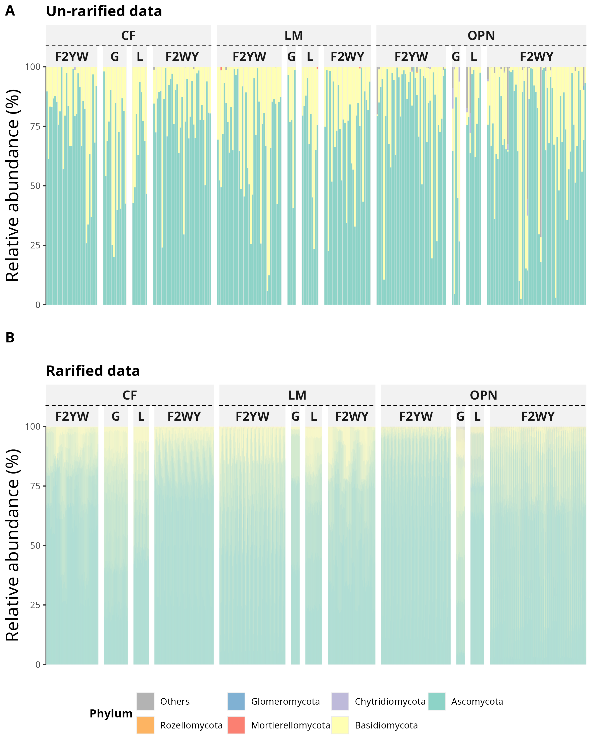

Relative abundance of fungal phyla in raw (A) and rarefied (B) data, by species and elevation category.

## 12.2 Figure 2

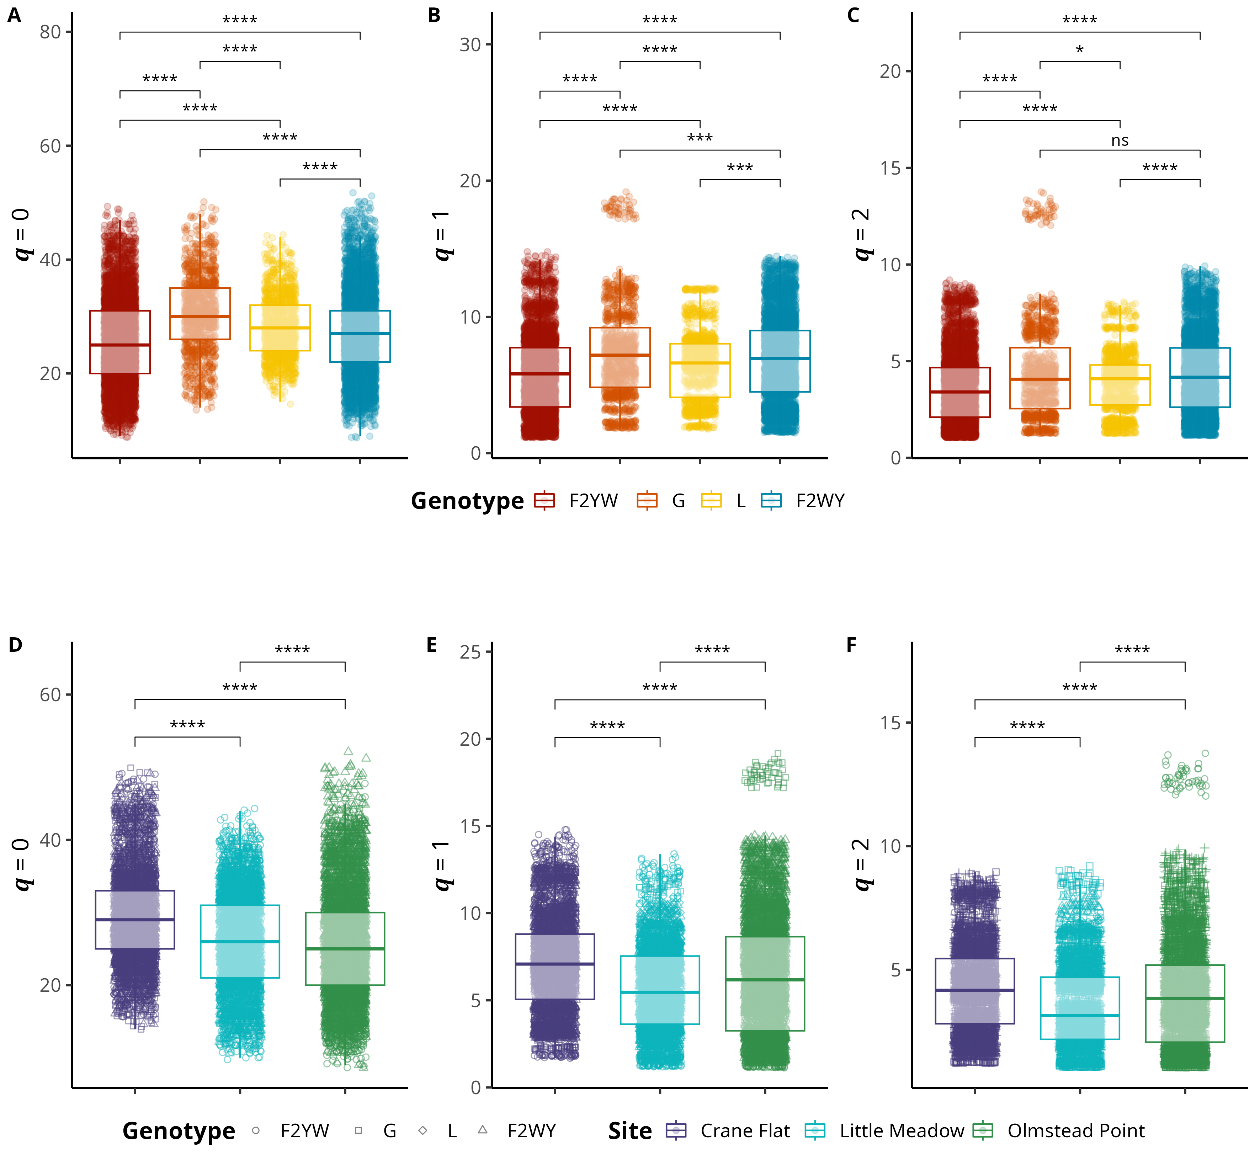

Alpha and beta diversity means comparisons in host species and habitat types. Alpha diversity means comparisons; A) Observed ASV richness (𝑞 = 0); B) Shannon’s entropy (𝑞 = 1); and C) Inverse Simpson’s index (𝑞 = 2) per host species. A-C) Red filled boxplots correspond to F2YW, orange filled to G (*M. guttatus*), yellow to L (*M. laciniatus*), and teal to F2WY genotype. Beta diversity mean comparions; A) Observed ASV richness (𝑞 = 0); B) Shannon’s entropy (𝑞 = 1); and C) Inverse Simpson’s index (𝑞 = 2)per elevation category. D-F) Light teal filled boxplot corresponds to Meadow 1, purple to Meadow 2, and light maroon to Granite 1. Open shapes represent: squares (F2YW), circles (G), triangles (L), and crosses (F2WY). Significance levels are represented by *ns* (not significant) and asterisks [*p* < 0.05 (*), *p* < 0.01 (\**),* p* < 0.001 (\***), and *p* < 0.0001 (\***\*)].

## 12.3 Figure 3

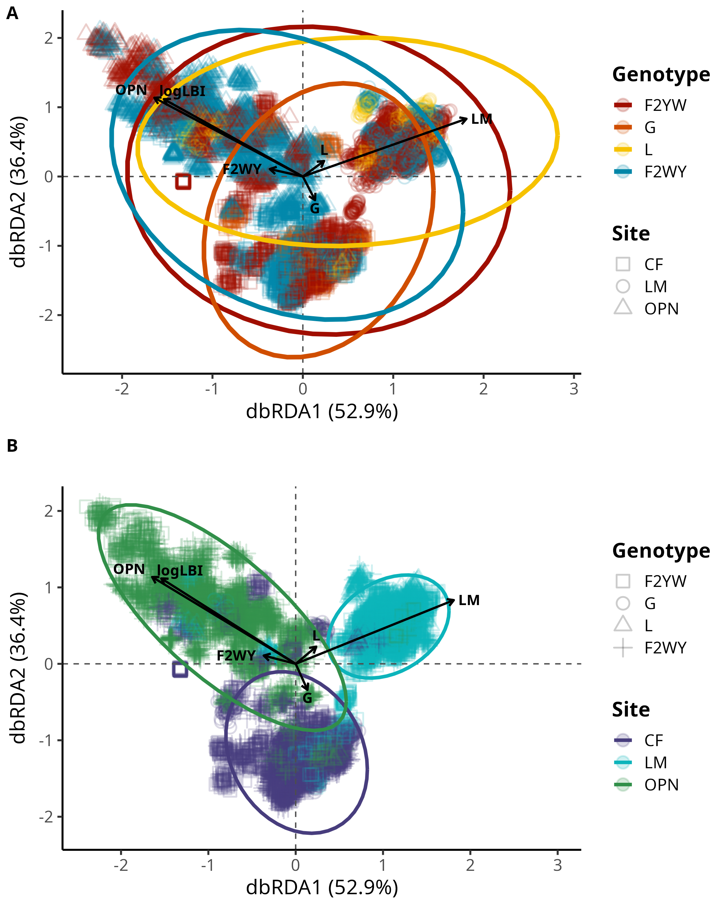

FEF community composition association with leaf functional traits and elevation per host species. Distance-based Redundancy Analysis (dbRDA) plot of rarefied FEF community and leaf functional traits by species. A) Each cluster of points represents a rarefied FEF community sample from one host species; blue filled squares correspond to *M. laciniatus*, green circles to *M. nasutus*, and yellow triangles to *M. guttatus*. B) Purple filled shapes correspond to LOW elevation, pink chapes to MID elevation and light maroon shapes to HIGH elevation. Point shapes correspond to host species. Solid arrow lines represent significant associations (*p* <0.01), while dashed lines represent non-significant associations. The length and direction of the arrows indicate the strength and direction of the association between the traits and the FEF community composition. The labels on the arrows correspond to the leaf functional traits. Ellipses represent 95% confidence intervals. The plot is based on the Bray-Curtis dissimilarity matrix.

## 12.4 Figure 4

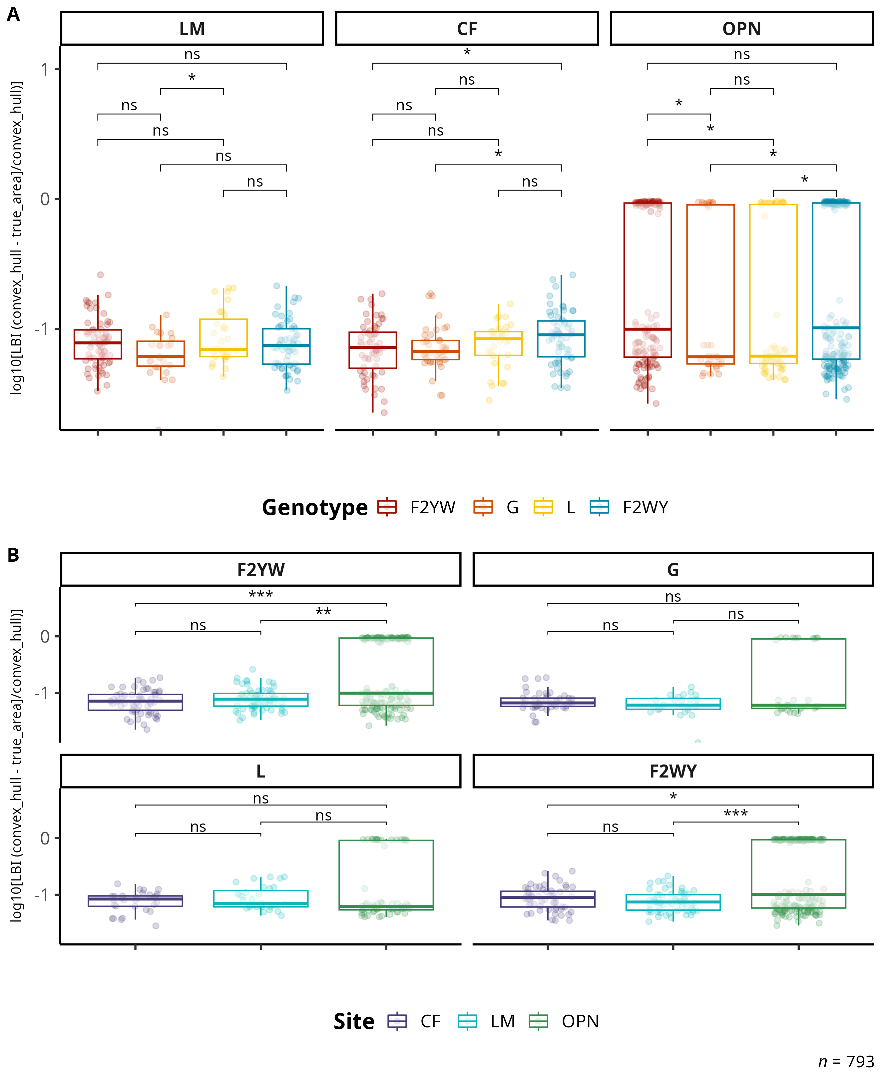

Change in log-transformed leaf lobe index (LBI) by genotype and habitat. A) Compares logLBI means by species and habitat category. The black line across violins represents the mean value. B) Change in logLPS per species as elevation increases. The black trend line represents the fitted model for all data points, see main text for R squared and *p* values. Significance levels are represented by *ns* (not significant) and asterisks [*p* < 0.05 (*), *p* < 0.01 (\**),* p* < 0.001 (\***), and *p* < 0.0001 (\***\*)].

# 13. Supplementary Material

## 13.1 Figure S1

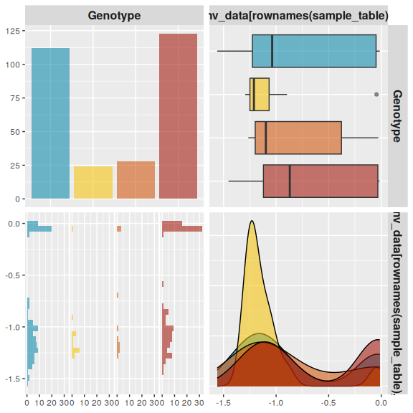

Correlation matrix of log-transformed leaf functional traits by host species. The plot is based on the Spearman’s rho. Significance levels are represented by ns (not significant) and asterisks [p < 0.05 (*), p < 0.01 (****), p < 0.001 (***), and p < 0.0001 (****)].

## 13.2 Figure S2

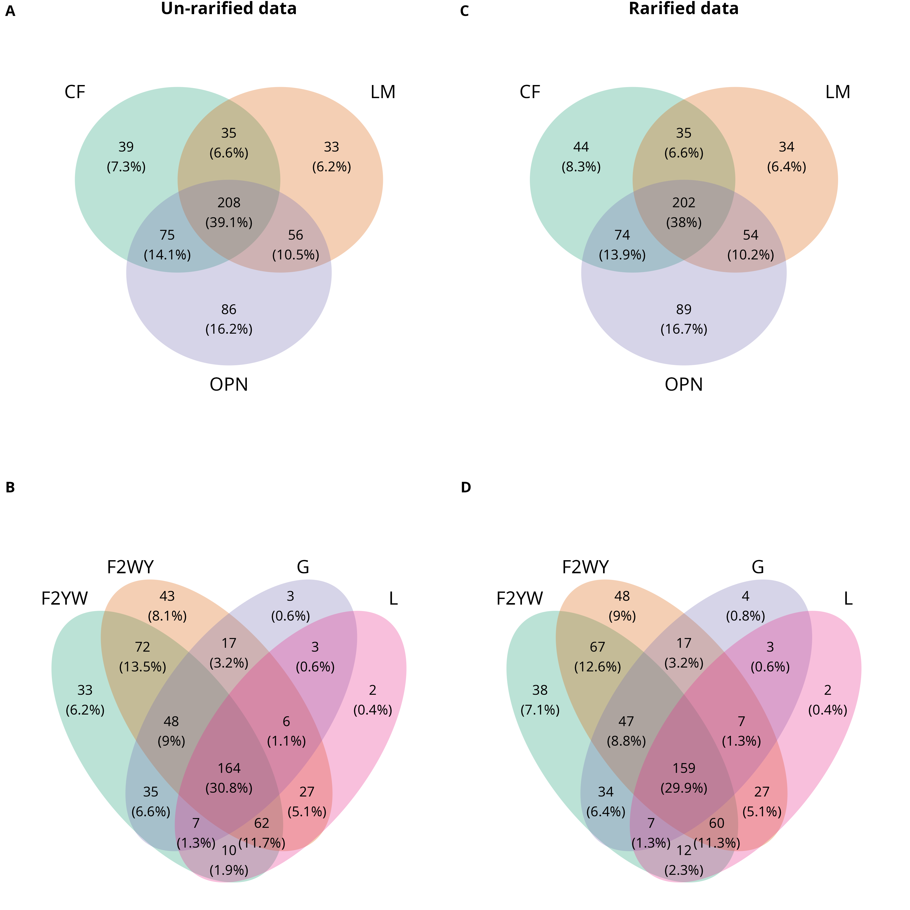

## 13.3 Figure S3

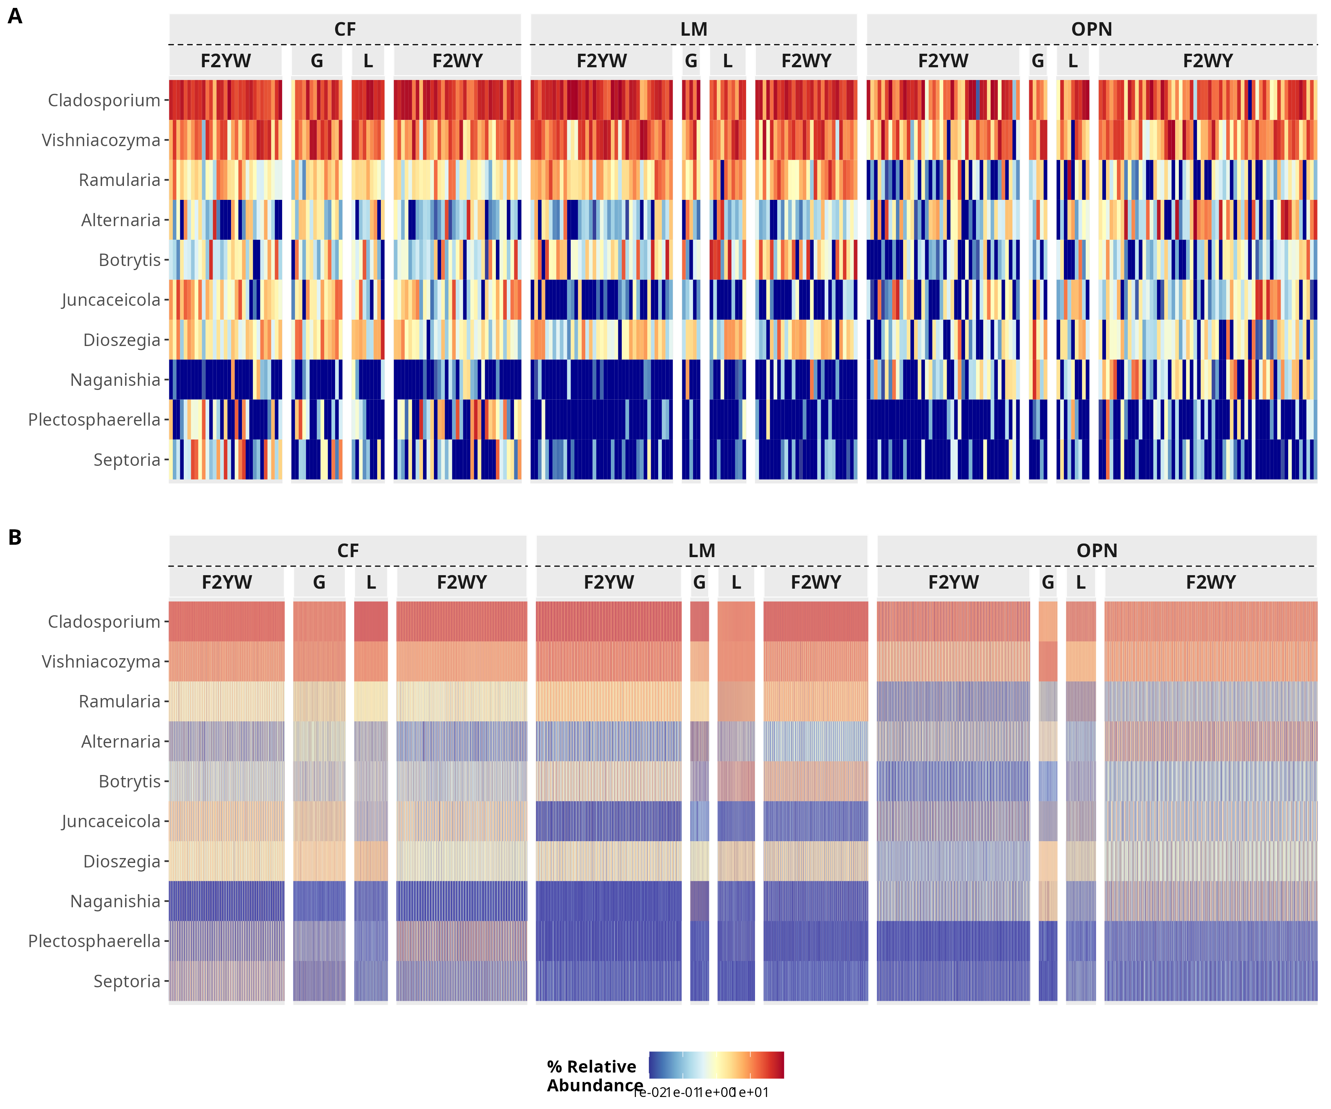

Heatmap of the top 10 most abundant genera in the dataset. The heatmap is faceted by habitat type and genotype.

## 13.5 Table 1

## Table 1: Core taxa members in the dataset.

| ASV | Kingdom | Phylum | Class | Order | Family | Genus | Species |
| --- | --- | --- | --- | --- | --- | --- | --- |
| ASV_1 | Fungi | Ascomycota | Dothideomycetes | Capnodiales | Cladosporiaceae | Cladosporium | NA |
| ASV_2 | Fungi | Basidiomycota | Tremellomycetes | Tremellales | Bulleribasidiaceae | Vishniacozyma | victoriae |
| ASV_3 | Fungi | Ascomycota | Dothideomycetes | Pleosporales | Didymellaceae | NA | NA |
| ASV_4 | Fungi | Ascomycota | Leotiomycetes | Helotiales | Sclerotiniaceae | Botrytis | caroliniana |
| ASV_5 | Fungi | Basidiomycota | Tremellomycetes | Tremellales | Bulleribasidiaceae | Dioszegia | patagonica |
| ASV_6 | Fungi | Ascomycota | Dothideomycetes | Capnodiales | Cladosporiaceae | Cladosporium | NA |
| ASV_7 | Fungi | Ascomycota | Dothideomycetes | Mycosphaerellales | Mycosphaerellaceae | Ramularia | NA |
| ASV_8 | Fungi | Ascomycota | Dothideomycetes | Pleosporales | Pleosporaceae | Alternaria | tenuissima |
| ASV_9 | Fungi | Basidiomycota | Tremellomycetes | Tremellales | Bulleribasidiaceae | Vishniacozyma | heimaeyensis |
| ASV_11 | Fungi | Basidiomycota | Tremellomycetes | Tremellales | Bulleribasidiaceae | Vishniacozyma | heimaeyensis |
| ASV_12 | Fungi | Basidiomycota | Tremellomycetes | Tremellales | Bulleribasidiaceae | Vishniacozyma | tephrensis |
| ASV_14 | Fungi | Basidiomycota | Tremellomycetes | Tremellales | Bulleribasidiaceae | Vishniacozyma | tephrensis |
| ASV_16 | Fungi | Ascomycota | Dothideomycetes | Mycosphaerellales | Mycosphaerellaceae | Ramularia | hydrangeae-macrophyllae |
| ASV_18 | Fungi | Ascomycota | Dothideomycetes | Mycosphaerellales | Mycosphaerellaceae | Ramularia | NA |
| ASV_19 | Fungi | Basidiomycota | Tremellomycetes | Tremellales | Bulleribasidiaceae | Vishniacozyma | victoriae |
| ASV_21 | Fungi | Ascomycota | Dothideomycetes | Capnodiales | Cladosporiaceae | Cladosporium | NA |
| ASV_23 | Fungi | Ascomycota | Dothideomycetes | Capnodiales | Cladosporiaceae | Cladosporium | NA |
| ASV_27 | Fungi | Ascomycota | Dothideomycetes | Capnodiales | Cladosporiaceae | Cladosporium | herbarum |

## 13.6 Table 2

Table 2: Prevalence of phyla in samples per genotype.

| Genotype | Phylum | Ocurrance in samples |
| --- | --- | --- |
| F2YW | Ascomycota | 112 |
| F2YW | Basidiomycota | 111 |
| F2YW | Chytridiomycota | 4 |
| F2YW | Mortierellomycota | 6 |
| F2YW | Rozellomycota | 1 |
| G | Ascomycota | 24 |
| G | Basidiomycota | 24 |
| G | Chytridiomycota | 5 |
| L | Ascomycota | 28 |
| L | Basidiomycota | 28 |
| L | Chytridiomycota | 2 |
| L | Mortierellomycota | 2 |
| L | Rozellomycota | 1 |
| F2WY | Ascomycota | 123 |
| F2WY | Basidiomycota | 123 |
| F2WY | Chytridiomycota | 6 |
| F2WY | Glomeromycota | 2 |
| F2WY | Mortierellomycota | 3 |
| F2WY | Rozellomycota | 1 |

## 13.7 Table 3

Missing

## 13.8 Supplementary methods

### 13.8.1 Illumina TruSeq adapters for ITS sequencing

The modified primers for the first PCR (adapter ligation and ITS1 amplification) were as follows: 5’-CAC TCT TTC CCT ACA CGA CGC TCT TCC GAT CTC TTG GTC ATT TAG AGG AAG TAA-3’ (forward) and 5’-GTG ACT GGA GTT CAG ACG TGT GCT CTT CCG ATC TGC TGC GTT CTT CAT CGA TGC-3’ (reverse).

See (Gardes & Bruns, 1993) and (White et al., 1990) for more details.

### 13.8.2 IDT BestRAD barcodes and *i5* custom oligos

####BestRAD adaptors: Top oligo Anatomy: biotin spacer SbfI barcode overhang Sequence: /5Biosg/GTACGT CCTGCAGG NNNNNNN TGCA Bottom oligo Sequence: /5Phos/NNNNNNN CCTGCAGG ACGTAC

#### 13.8.2.1 BestRAD *i5*

5’-AAT GAT ACG GCG ACC ACC GAG ATC TAC ACN NNN NNN NAC ACT CTT TCC CTA CAC GAC GCT CTT CCG ATC*T-3’